Professional, Proud and Passionate

**Gender Pay Gap Report**

**2022 - 2023**



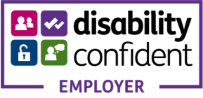**http://staffzone/web-images/logos/Mindful%20Employer%20logo%20EPS%20PC.gif**

1. **About QE Facilities**

QE Facilities Ltd (QEF) is a wholly owned subsidiary company of Gateshead Health NHS Foundation Trust, based in the Northeast of England. The organisation provides a range of estates, facilities management, pharmacy, procurement, and transport services to Gateshead Health NHS Foundation Trust and other external health and social care organisations.

QE Facilities is committed to the promotion of diversity, equality of opportunity and choice for all employees. Our aim is that our workforce is not only diverse and inclusive but is also truly representative of the communities we serve.

QE Facilities strives to create an environment where our staff consider that we provide equal opportunities and take action against any discrimination we are not complacent and set annual priorities around our Public Sector Equality Duties. We can use the results of this Gender Pay Gap report to assess the levels of gender equality in our workplace, the balance of male and female employees at different levels, how effectively talent is being maximised and rewarded.

QE Facilities supports the fair treatment and reward of all staff irrespective of gender or any other protected characteristic. In producing this report, we recognise that we have more to do to reduce the gender pay gap and we remain committed to a workplace that respects and harnesses equality and diversity. We will work to improve the gender pay gap by undertaking the actions set out at the end of this report.

Established in 2014, the organisation had 766 paid staff on 31st March 2023.

1. **Gender Pay Gap Reporting Requirements**

The Equality Act 2010 (Specific Duties and Public Authorities) Regulations 2017 (the Regulations) require public sector organisations with over 250 employees to report on and publish their gender pay gap on a yearly basis. This is based on a snapshot from 31st March of each year, and each organisation is duty bound to publish information on their website.

The gender pay gap is a defined term in the Regulations and means the difference between the average hourly earnings of men and those of women. This is not the same as equal pay, which is concerned with men and women earning equal pay for the same jobs, similar jobs or work of equal value. It is unlawful to pay people unequally because of gender. Instead, the gender pay gap highlights any imbalance of average pay across an organisation. For example, if an organisation’s workforce is predominantly female yet the majority of senior positions are held by men, the average female salary would be lower than the average male salary.

The requirements of the Regulations is that each public sector organisation must calculate the following:

* **Mean gender pay gap**: the difference between the mean hourly rate of pay of male and that of female full-pay relevant employees.
* **Median gender pay gap:** the difference between the median hourly rate of pay of male and that of female full-pay relevant employees.
* **Mean bonus gap**: the difference between the mean bonus pay paid to male and that paid to female relevant employees.
* **Median bonus gap:** the difference between the median bonus pay paid to male and that paid to female relevant employees.
* **Bonus proportions**: the proportions of male and female relevant employees who were paid bonus pay.
* **Quartile pay bands:** the proportions of male and female full-pay relevant employees in the lower, lower middle, upper middle and upper quartile pay bands. (CIP

Our gender pay gap report data has been produced using a number of set reports available through the ESR (Electronic Staff Record) system.

**3. Who is included**

For the purposes of the Gender Pay Gap Report, the definition of who counts as an employee is defined in the Equality Act 2010. This is known as an ‘extended’ definition which includes:

* Employees (those with a contract of employment including apprenticeships)
* Workers and agency workers (those with a contract and do work or provided services)
* Some self-employed people (where they have to personally perform the work)

For the purposes of this report, agency workers will form part of the headcount of the agency that provides them, and not the employer they are on assignment to.

**4. Pay elements**

The statutory calculations have been undertaken using the standard national ESR Business Intelligence report.

Pay includes basic pay, full paid leave including annual leave, sick leave, maternity, paternity, adoption or parental leave, bonus pay, shift premium pay, pay for piecework and local agreements.

Pay does not include overtime pay, expenses (payments made to reimburse expenditure wholly and necessarily incurred in the course of employment, e.g. mileage for use of vehicle), remuneration in lieu of leave, the value of salary sacrifice schemes, benefits in kind (e.g. child care vouchers), redundancy pay and tax credits or pay referable to redundancy or termination of employment.

**5. QE Facilities Gender Profile**

The graphs below show an increase in WTE of 37 compared to the 2022 gender pay gap report. In 2023 The organisation has moved from a 50/50 spilt to a decrease in female establishment to 47% and increase in male establishment to 53%.

**6. Ordinary Pay**

The ordinary pay element is calculated after any salary sacrifice deductions are made, therefore lowering the actual pay. The gender split for such schemes will therefore affect the ordinary pay element. The table below shows a total of **40 staff members (30 male, 10 female)** use the Salary Sacrifice Scheme. The percentage figures (Male and Female) show who uses the scheme compared to the to the organisation total (766).

|  |  |  |  |  |
| --- | --- | --- | --- | --- |
| **Staff in organisation (766)** | **Male (30)** | | **Female (10)** | |
| **Salary Sacrifice Scheme** | **% of staff in scheme** | **% of staff** | **% of staff in scheme** | **% of staff** |
| **Cycle to Work Scheme** | 30.00% | 1.17% | 20.00% | 0.26% |
| **Lease Cars** | 63.33% | 2.48% | 80.00% | 1.04% |
| **Payments for Nursery** | 3.33% | 0.13% | 0.00% | 0.00% |
| **Childcare Vouchers** | 3.33% | 0.13% | 0.00% | 0.00% |

**Mean Gender Pay Gap**

|  |  |
| --- | --- |
| **Gender** | **Mean Hourly Rate** |
| **Male** | £14.52 |
| **Female** | £13.04 |
| **Difference** | 1.48 |
| **Pay Gap %** | 10.19 |

The ordinary pay percentage shows the difference between the mean average hourly rate of pay that male and female relevant employees receive.

The organisations mean gender pay gap is 10.19%.

**Median Gender Pay Gap**

|  |  |
| --- | --- |
| **Gender** | **Median Hourly Rate** |
| **Male** | £12.53 |
| **Female** | £11.99 |
| **Difference** | 0.54 |
| **Pay Gap %** | 4.32 |

The calculation shows the difference between the median hourly rate of pay that male and female relevant employees receive.

The organisations median gender pay gap is 4.32%

**Mean Bonus Gender Pay Gap**

|  |  |
| --- | --- |
| **Gender** | **Avg. Pay** |
| **Male** | 800.24 |
| **Female** | 551.06 |
| **Difference** | 249.19 |
| **Pay Gap %** | 31.14 |

The calculation shows the difference between the mean bonus pay that male and female full-pay relevant employees receive.

The organisations mean bonus gender pay gap is 31.14%

**Median Bonus Gender Pay Gap**

|  |  |
| --- | --- |
| Gender | **Median Pay** |
| Male | 961.54 |
| Female | 466.67 |
| Difference | 494.87 |
| Pay Gap % | 51.47 |

The calculation shows the difference between the median bonus pay that male and female relevant employees receive.

The organisations median bonus gender pay gap is 51.47%.

**7. Quartile pay bands**

The proportion of male and female full pay relevant employees in the equally sized lower, lower middle, upper middle and upper quartile pay bands is as follows:

|  |  |  |  |  |  |  |  |  |
| --- | --- | --- | --- | --- | --- | --- | --- | --- |
| **Year** | **Lower** | | **Lower Middle** | | **Upper Middle** | | **Upper** | |
| **Female** | **Male** | **Female** | **Male** | **Female** | **Male** | **Female** | **Male** |
| **2023** | 37.04% | 62.96% | 66.32% | 33.68% | 46.35% | 53.65% | 36.98% | 63.02% |
|  |  |  |  |  |  |  |  |  |

The lower quartile represents our lowest paid staff, and the upper quartile represents our highest paid staff.

The highest proportion of male employees per quartile is in the highest bracket whilst the lowest proportion is in the lower middle bracket which results in the gender pay gap of 10.19%.

**8. Bonus Pay**

The proportion of male and female employees who received these payments in the reference period are outlined below.

0.81% received a bonus

|  |  |  |  |  |  |
| --- | --- | --- | --- | --- | --- |
| **Gender** | **Employees Paid Bonus** | **%** | **Employees Not Paid Bonus** | **%** | **Total Relevant Employees** |
| Female | 119 | 29.90% | 279 | 70.10% | 398 |
| Male | 37 | 8.87% | 380 | 91.13% | 417 |

29.9% of female employees received a bonus payment in comparison to 8.87% of our male employees. Within this reference period the number of female employees receiving a bonus is higher than male employees.

**Female employees**

The only element classed as bonus for the purposes of this report is the Estates and Facilities Directorate Performance Agreement.

**Note:** Our long service awards are not included in the bonus calculations as they are a benefit in kind.

We have a higher percentage of our female workforce working part time in comparison to our male workforce.

**9. Conclusion**

The organisation has a gender pay gap of 10.19% in 2023. The gender pay gap is not because people who are doing the same jobs are being paid differently according to their gender instead it is because there are more men than women in higher paid roles. As an organisation we will take actions to ensure equal opportunities are available for career development, flexible working, and recruitment.

The organisation currently has a bonus pay gap of 31.14%. Departments eligible for the bonus scheme have paid bonus payments to a higher proportion of female than males. On average male employees receive a higher bonus payment than female employees.

**10. Action to reduce the pay and bonus gap**

|  |  |  |
| --- | --- | --- |
| Action | Review |  |
| Monitor and review gender pay gaps | Annually | April 2023 |
| Ensure the organisation has an inclusive recruitment process. Continue to develop flexible working options and workforce strategies to improve recruitment and retention of staff, including supporting female staff to return to work following maternity or adoption leave | Ongoing | Annually |
| Review mechanisms for career progression/staff development/talent management. To ensure equality and inclusivity within process | Ongoing | Annually |
| Promotion and Awareness of the Group Equality, Diversity, and Inclusion Strategy | Ongoing | Annually |

**Statement**

I confirm that QE Facilities is committed to the principle of gender pay equality and has prepared this report in line with mandatory requirements.

Name: Mr Gavin Evans

Job Title: QE Facilities Managing Director

Signature: 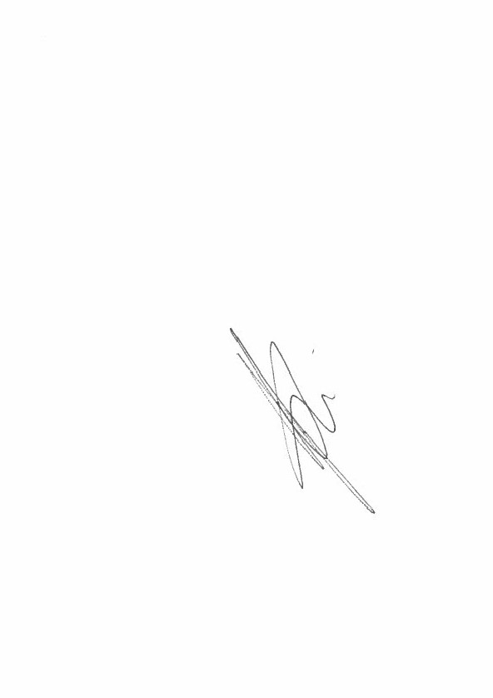

Date: 2 April 2024

**If you require a copy of this report in a different format, please contact the People and OD team at** [**ghnt.pod@nhs.net**](mailto:ghnt.pod@nhs.net)